Name:Tasnia Tapti ,ID-19-40005-1

**Features**

Features are listed below.  **High**, **Medium** and **Low** are used to indicate the importance of each feature.

|  |  |  |  |
| --- | --- | --- | --- |
| **Feature ID** | **Description** | **Priority** | **Requester** |
| **FE01** | Web based and accessible from devices (with internet connection) mobile and tablet PCs. | High |  |
| **FE02** | Accessible only to authenticated and authorized users | High |  |
| **FE03** | Data management for example:  User details, train schedule, update time and so on.  It will also allow users search and viewing arrival time | High |  |
| **FE04** | Report generation based on user needs. | Medium |  |
| **FE05** | User management and auditing user activities | High |  |
|  |  |  |  |

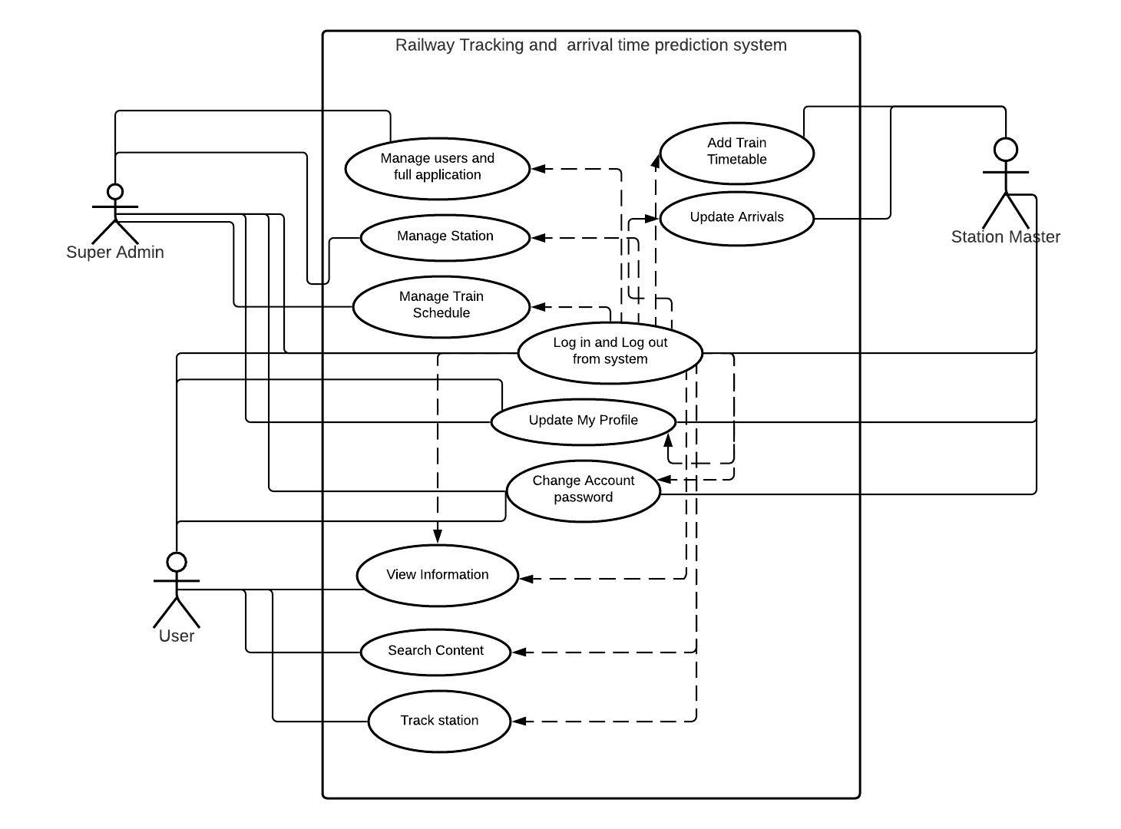

|  |  |
| --- | --- |
| **FE02 - Authentication and authorization** | |
| **FE02_UC01** - User authentication | |
| **Brief Description** | The user opens up the portal and the portal shows the login form for access. |
| **Pre-condition/s** | * User is not logged in already |
| **Priority** | High |
| **Actor/s** | Users of all classes. |
| **Main Success Scenario** | 1. User opens up the web portal 2. The system displays a login form 3. User enters his/her user id and password 4. The system matches user credentials against its date store 5. The system then redirects user to the appropriate page based on user class. |
| **Alternative Scenario** | * The system cannot find a match for the user and re-displays the login form with an error message. * The system runs into internal error (i.e. database unavailable) and notifies user and asks the user to contact administrator |
| **Notes/Questions** | Must need clarification on dashboard for each user type. |
|  |  |

|  |  |
| --- | --- |
| **FE03 - Employee data management** | |
| **FE03_UC01** - Add new employee | |
| **Brief Description** | User wants to add actual timetable of train schedule |
| **Pre-condition/s** | * User must be logged in |
| **Priority** | High |
| **Actor/s** | Super Admin, Station Master |
| **Main Success Scenario** | 1. The system displays a form with all the necessary fields required to collect station information. These fields will be Station Name, Train Name, Arrival Time and all information. 2. When all the information is put the system generates a successful operation message and updates all the information properly in the database. |
| **Alternative Scenario** | * The system is unable to store the information in database and generates operation not complete message. |
| **Notes/Questions** | The system will not store information from incomplete form. A form will be incomplete when all the ‘must be filled’ fields are not filled. |

|  |  |
| --- | --- |
| **FE03_UC02** - View Arrival Time | |
| **Brief Description** | The system will display train timing information |
| **Priority** | High |
| **Actor/s** | Super ADMIN, Station Master |
| **Main Success Scenario** | 1. The user can update train time in different station. 2. The clients will be able to view delay of train arrival timing |
| **Alternative Scenario** | * The system is unable to extract timing information from the database and generates error message |
| **Notes/Questions** | The types of views must be mentioned |